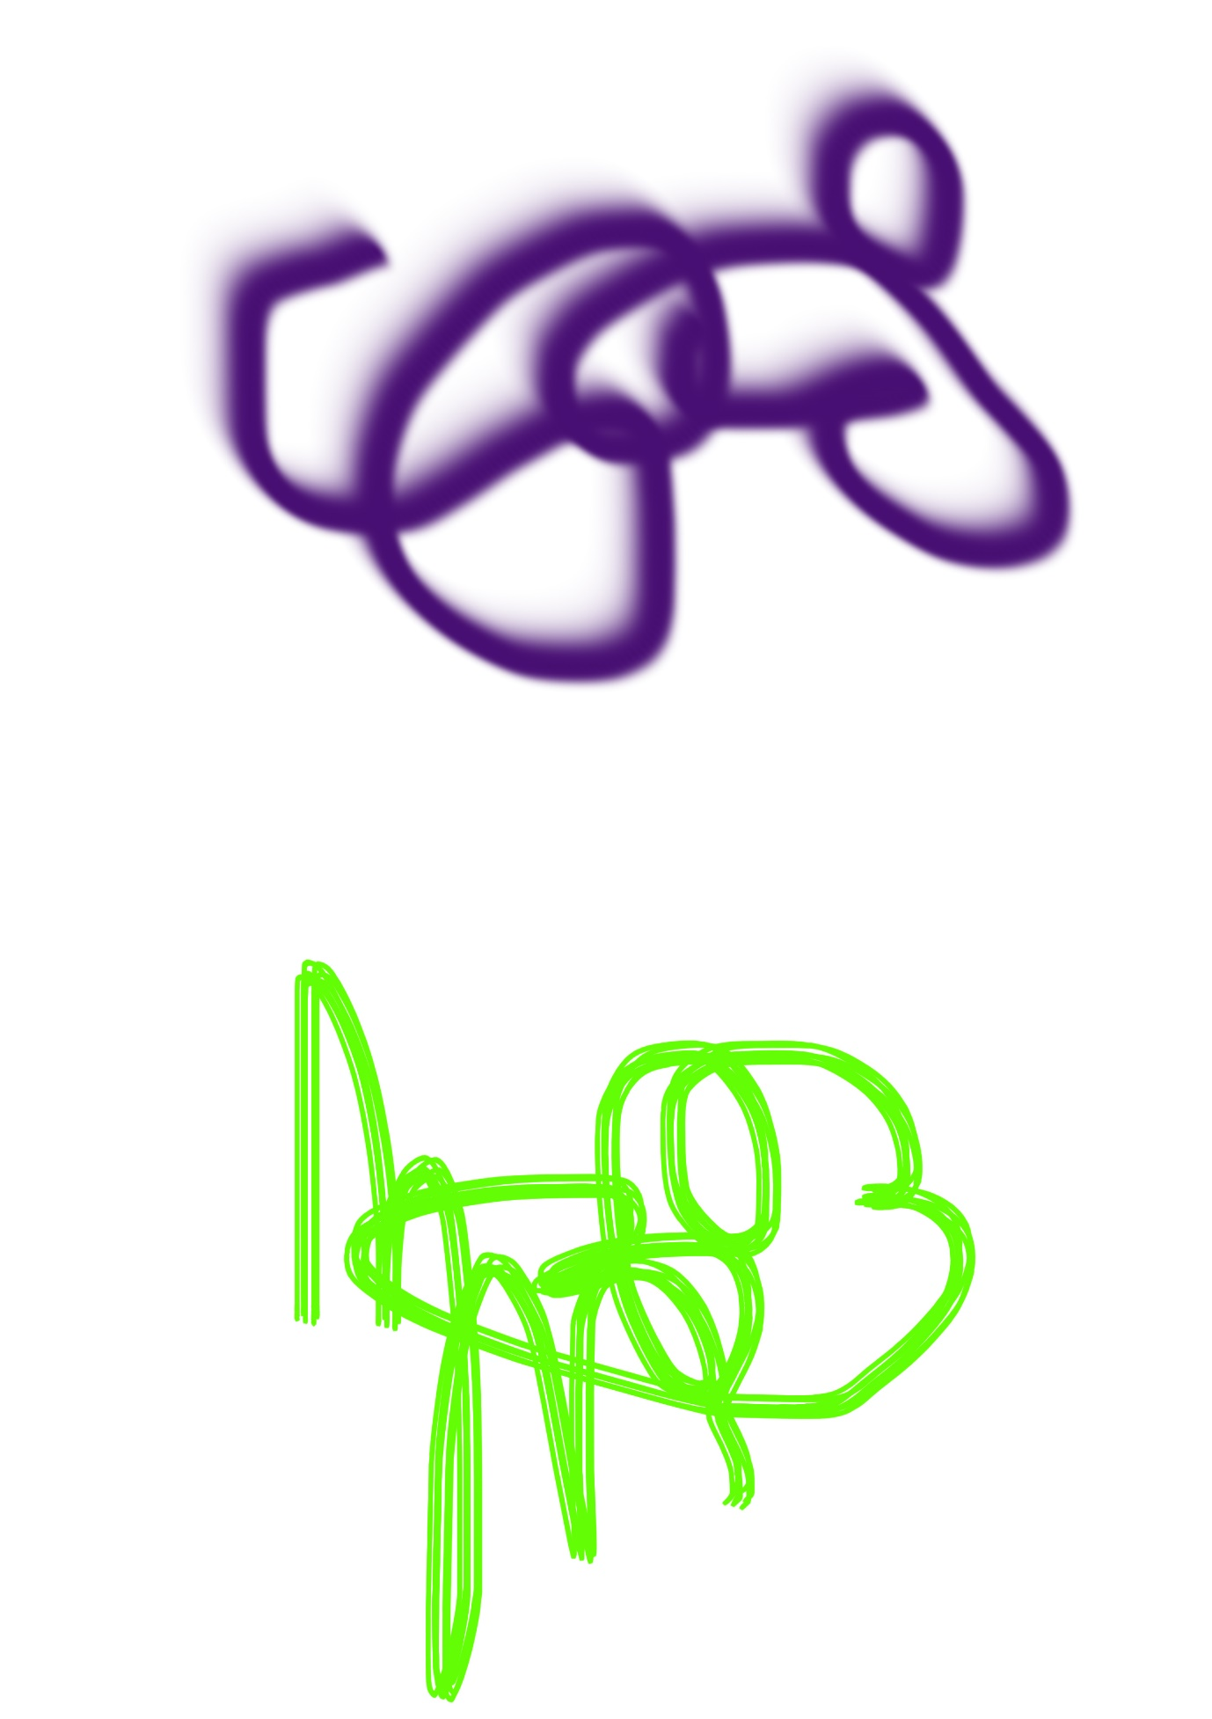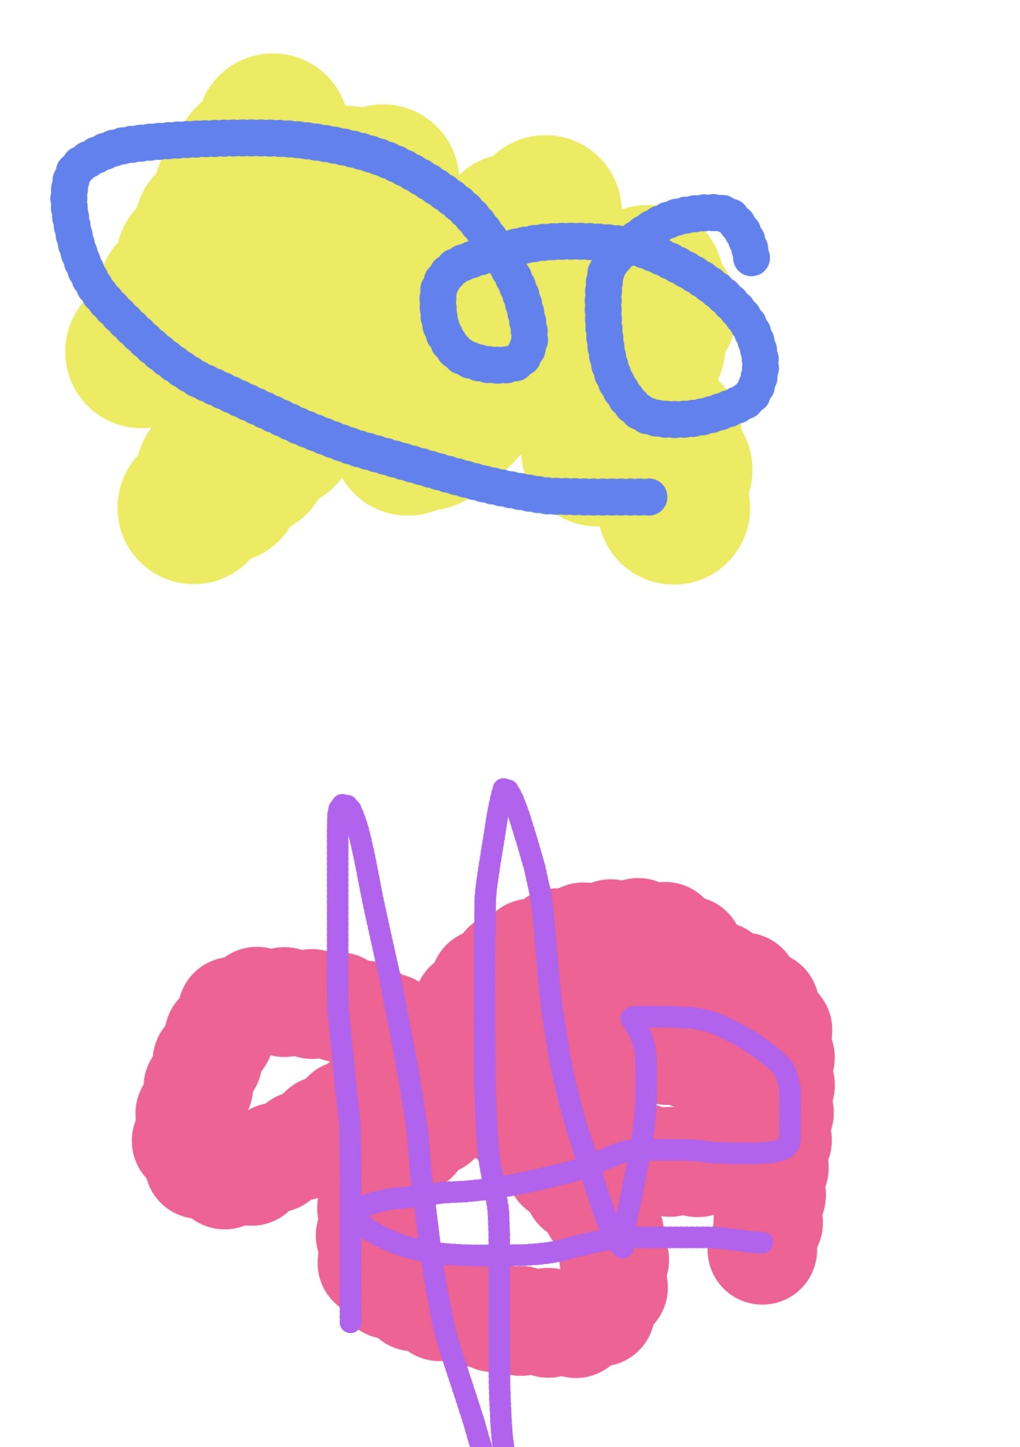

Can you add features to the scribbles above to turn them in to creatures?
Print the work sheets off above and add more detail using coloured pencils, felt tips or pens.

The example below was created quickly on the computer as an example, you could take your time to draw your own by hand making it more detailed.
You could even create your own scribble on to some paper and then add features to it.
You could add anything;
- Eyes, mouth, nose, funny clothing, hats, hair, alien features (antenna, multiple eyes)

