Read the following paragraph and answer the questions
Week commencing 15th June 2020
English
Captain Tom Moore

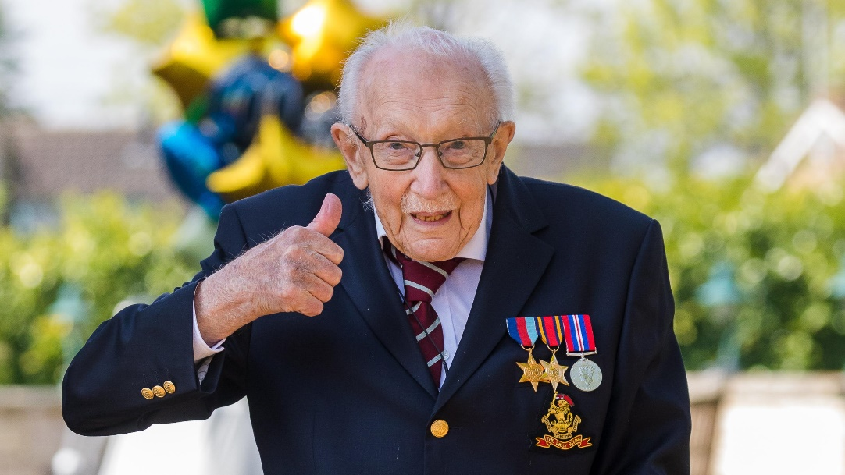
Captain Tom Moore is the ex-soldier who made headlines around the world in April 2020, when he set out to raise money for the National Health Service, by walking 100 laps around his garden. Not only did he raise an incredible amount of money, but he also broke several world records at the same time. Who is Captain Tom Moore? Captain Tom was born in Yorkshire on 30th April 1920. He was a soldier in the British Army and served in the Second World War. He currently lives in Bedfordshire with one of his two daughters and her family. Captain Tom saw the hard work the hospital staff were doing, when he watched the news during the COVID-19 crisis. Because of this and because he had been well looked after in hospital himself, he decided that he wanted to do something to raise money for the National Health Service (NHS). Why 100? Captain Tom began his challenge as a 99 year old. He decided to walk 100 laps of his garden (10 each day), leading up to his 100th birthday, which was on 30th April 2020. He set himself a target of £1000, which he reached in a day. Captain Tom completed his laps with the aid of a walking frame. By the time he finished the 100 laps, he had raised over 27 million pounds! Breaking Records With his story shared around the world, more and more people donated money and Captain Tom broke several records during his fundraising efforts. Captain Tom Moore He has raised more money from a charity walk than any other single person. He released a charity song, which became the highest selling single of 2020. He is the oldest person ever to have a song at number one in the charts. Tom completed his 100 laps two weeks before his birthday, so decided to increase the number of laps he walked to 200.

Answer the following questions
- What did Tom Moore do for a profession?
- Why did he make headlines in April 2020?
- What did he set out to do?
- Who did he raise money for?
- What world records did he break?
- Where was Captain Tom Moore born?
- When was he born?
- Which war did Tom Moore serve in?
- Where does Captain Tom Moore live?
- Who does he live with?

If you need to get in touch contact me at:
llord@beverleyschool.org.uk

