See if you can complete the word search below:
Week commencing 15th June 2020
Horticulture/ TVWT
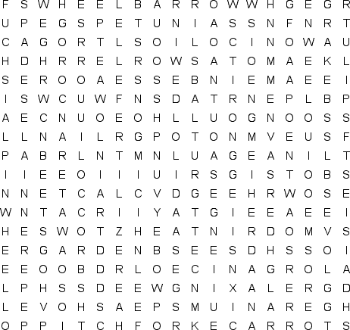
ANNUALS GLOVES GNOME
GREENHOUSE GROW HOES
HORTICULTURE BEANS BEETS
BIENNIAL BROCCOLI CARROTS
COMPOST CUTIVATE DAISIES
DIGGING FERTILIZER FLOWERS
FUCHSIA GARDEN GERANIUMS HOSE
HYDRANGEA LILACS LILIES
MARIGOLDS ORGANIC PEAS
PERENNIALS PETUNIAS PINWHEEL
PITCH FORK PLANTING RAKE
RAIN RELAXING ROSES
ROWS SEEDS SHOVEL
SOIL SPADE SUNSHINE
TOMATOES TROWEL TULIPS
VEGETABLES WATER WEEDS
WHEELBARROW

