Fill in the missing times
Week commencing 22nd June 2020
Maths
Remember there are 12 hours on a clock face
There are 24 hours in a day.
Time in words | 24hr clock | 12 hr clock | Analogue
seven o’clock in the evening | 19:00 | 7:00p.m. | 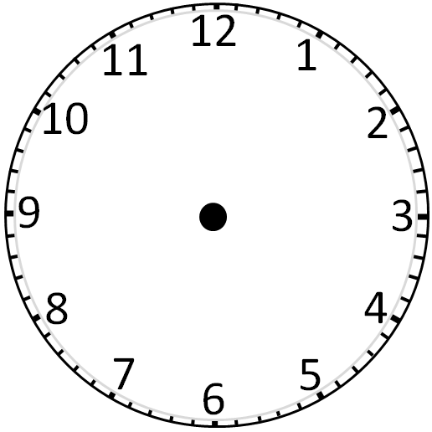
 |  | 11:00a.m
 | 14:15
 |  | 8:20p.m
midday

 |  | 6:40p.m.
midnight

seven minutes to eight at night

 | 15.15

If you need to get in touch, contact me at:
llord@beverleyschool.org.uk

