Week commencing 13th July 2020

Horticulture/ TVWT

Hello I hope you have enjoyed the work I have put on the school website.

This is the last week of work before you break for the summer.

Make a pair of binoculars and keep busy looking at the wildlife and the environment. See how many different birds and mini beasts you can see through your binoculars.

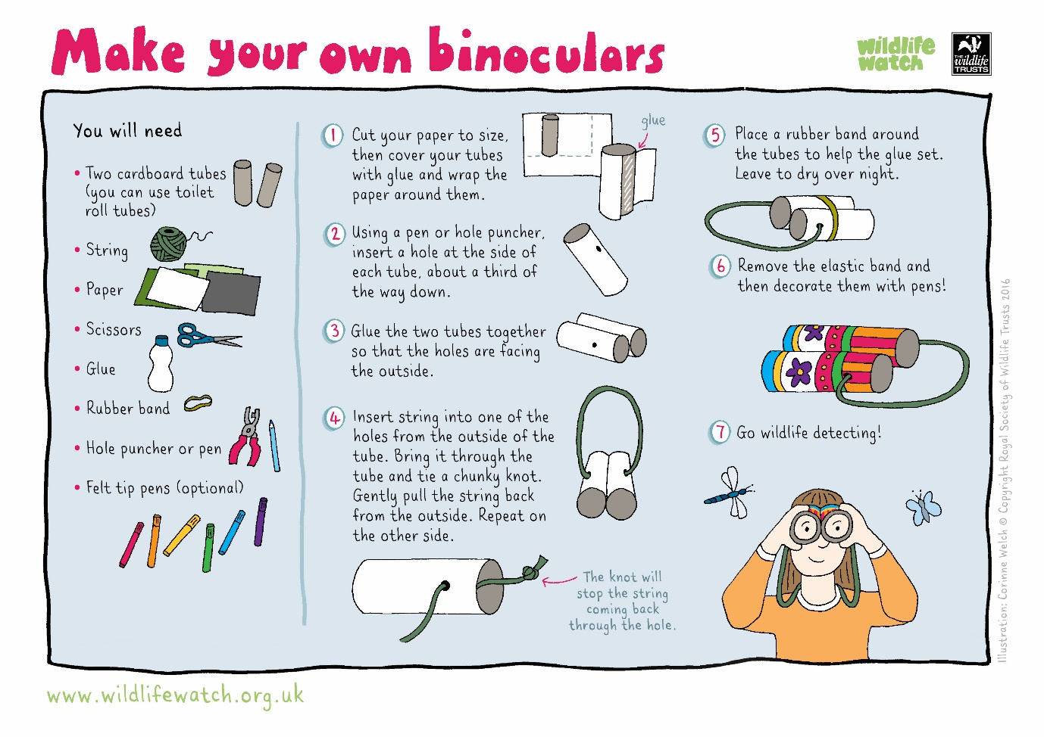

If you need to get in touch, contact me at:

[llord@beverleyschool.org.uk](mailto:llord@beverleyschool.org.uk)

Enjoy the summer break and I look forward to seeing you in September.