I hope you have enjoyed the work that I have put on the school website. This is the last week of work before the summer holidays.
Week commencing 13th July 2020
Maths
How many more
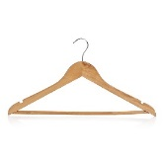
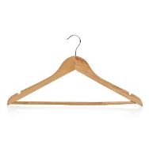
1 Jo has 9 shirts to put on hangers
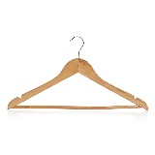
He has these hangers already
How many more hangers does Jo need?
Show your working out in the box below

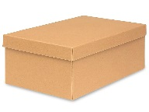
2. Kate has 6 pairs of shoes she needs to put all her shoes in a box. She has these boxes already
How many more boxes does she need?
Show your working out in the box below

3. Mark has 50 books. He needs to put the books on a bookcase. Each bookcase can hold 10 books. He has these bookcases already. How many more does he need?
Show your working out in the box below

4. Jane needs to put he handbags in the draws. Each draw can hold 4 bags. How many bags can she put in the draws 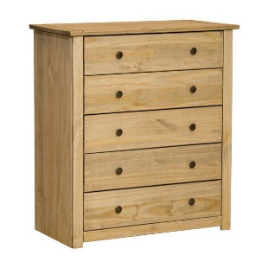
Show your working out in the box below

If you need to get in touch, contact me at:
llord@beverleyschool.org.uk

