This week think about something you could grow
Week commencing 6th July 2020
Horticulture/ TVWT
It might be a plant bought from a garden centre, or some seeds from a supermarket.
If you have plants in your garden, see if you can take some cuttings from it and try to grow a new plant.
You can also cut a tomato in half and dry out the seeds and plant them in some compost and grow a tomato plant. You can do this with peppers too.
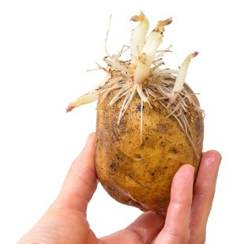
To grow potatoes, leave a potato in a dark place for about a week and it should start to produce a root, you can then plant it to grow a potato plant.

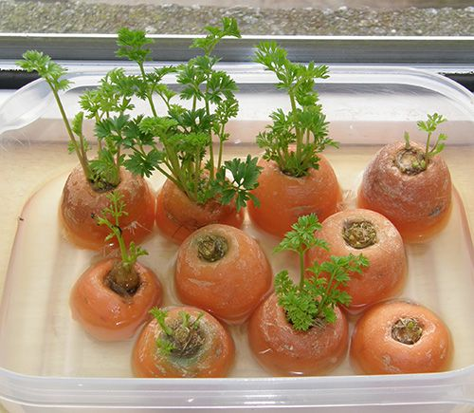
You can also cut the top off a carrot and put it in a shallow bowl of water and it should sprout from the top.

if you do not have any plant pots you can use an empty toilet roll or kitchen roll

Here are a few tips on how to use toilet paper rolls to house seedlings:
- Make a series of 1 to 1 1/2-inch cuts around one end of the roll, approximately a half an inch apart.
- Fold the cut sections in toward the centre of the roll. ...
- Place the seed pots on a tray, plate, or bow
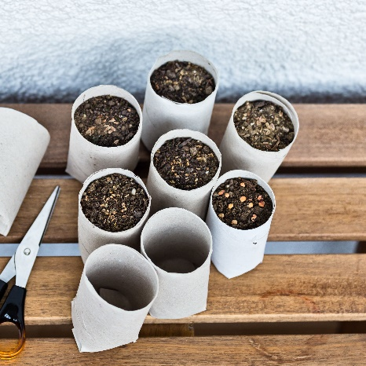

If you need to get in touch, contact me at:
llord@beverleyschool.org.uk

